2020 Quarterly Program Activity Overview (Revised)
(Replaces the former Monthly Report. PLEASE CONTACT THE TMSP OFFICE FOR YOUR INDIVIDUALIZED QUARTERLY REINVESTMENT WORKSHEET)

PROGRAM NAME: Mineola Main Street
THIS REPORT COVERS (please indicate):
☒ QUARTER 1 (January 2020-March 2020, due April 10th)
☒ QUARTER 2 (April 2020-June 2020, due July 10th)
☐ QUARTER 3 (July 2020-September 2020, due October 10th)
(QUARTER 4 Activity will be reported as part of the annual report that will be due in December 2020.)

NOTE: The original 2020 template has been revised so that you can also report on COVID impacts and how your program/downtown is adapting. Some of the information is from the original template prior to the arrival of the pandemic. This revised template reflecting current circumstances will help us -- all working together --prepare for an uncertain future; and to document what is being done in our Main Street world to prepare for it.

This Quarterly Activity Overview replaces the former Monthly Report and is to be turned in along with each quarter’s reinvestment report (provided separately). It aligns with the national office’s new Community Accreditation Standards (the former 10 Criteria), which is now a strong component of determining National Accreditation and Texas Recognition. This new template should allow you to more efficiently and effectively complete the annual self-evaluation (to be distributed in late fall 2020). Please use this template to briefly summarize activity as they relate to the revised performance standards:

1. Broad‐based Community Commitment – Six of our Main Street businesses have told me they’re either doing well, better than before the pandemic, or better than this time last year. One of our Main St. District banks bought lunches for all 39 employees from local restaurants. Members of the community are making a point of supporting our restaurants.
2. Leadership & Organizational Capacity – Flexible during this time. Main Street Board resumed meeting with in-person and Zoom option in June. Email, personal messages, texts and telephone communications have allowed us to continue our mission.
3. Diverse and Sustainable Funding – Due to loss of our biggest fundraiser, Main Street has applied for grants from our city’s economic development board, as well as the county economic development board. We are waiting to hear about the outcome. We will develop new fundraisers ASAP.
4. Strategy‐Driven Programming (Community Transformation Strategies) A local communications company is providing fiber optic through our town to make internet capabilities available.
5. Preservation‐Based Economic Development – The Landmark Commission has approved six Certificates of Appropriateness for a new restaurant’s signs, an under-construction business’ entry (3 different times due to owner changing mind) and signs, a new canopy, windowsills being painted a different color, and cosmetic work to be done on a photography studio façade.
6. Demonstrated Impact & Result – During the last two months, sales tax rebates for taxes collected during the pandemic have been up. Merchants have expressed their appreciation for our program’s communications and support during the virus.

https://www.mainstreet.org/mainstreetamerica/theapproach
“The Main Street Approach is centered around Transformation Strategies. A Transformation Strategy articulates a focused, deliberate path to revitalizing or strengthening a downtown or commercial district’s economy.”

We have adopted and articulated our Main Street strategy or strategies ☐Yes ☒ No
Please summarize your strategy or strategies: Still learning about this. Our strategy has not been articulated in a different way but it remains the same, to assistance our businesses financially as we are able to improve their structures as well as promoting their existence and maintaining the historical integrity of our town.

How do you expect COVID to impact these strategies/your work? It is complicating and slowing everything down. Our central focus will be fundraising to provide assistance to business people who want to improve their structures while enhancing the overall appearance of our Main Street District while doing what we can to preserve our historic integrity.

Please provide a brief description of activity below. Use as much space as necessary. Add summaries, images, sample media coverage etc. on an extra page(s) to further describe activities if desired. (not required)

ECONOMIC VITALITY. Focuses on capital, incentives, and other economic and financial tools to assist new and existing businesses, catalyze property development, and create a supportive environment for entrepreneurs and innovators that drive local economies. How has COVID impacted downtown/your program’s work in this area? Have you changed course? What do you expect for the future?
We have had more incentive grant requests during COVID, which also necessitated cancelling of our major fundraiser. We send out regular emails and strive to be responsive to any questions posed to us by our merchants.

DESIGN. Supports a community’s transformation by enhancing the physical and visual assets that set the commercial district apart. Please provide images/descriptions on separate pages for any physical improvements completed during the quarter (before/after). These should also appear in your reinvestment reports. How has COVID impacted downtown/your program’s work in this area? Have you changed course? What do you expect for the future?
At this point, due to cancellation of our largest fundraiser, our program is almost out of funds for incentive grants. We are still awaiting completion by the business people to receive reimbursement from Main Street. The change of course is the application for funds from the city and the county.

PROMOTION. Positions the downtown or commercial district as the center of the community and hub of economic activity, while creating a positive image that showcases a community’s unique characteristics. How has COVID impacted downtown/your program’s work in this area? Have you changed course? What do you expect for the future?
Our city has tried to promote our downtown restaurants that were closed with a restaurant guide and reserved parking carryout signs. One of our art major board members created some signs to lift peoples’ spirits that were posted at the chamber of commerce (we were hesitant of how much to do to early on, due to many people in our area believing the pandemic was politically motivated. Some still do.) We worked with the city and school district to support this year’s graduating class with photo signs hung on our period street light lamp posts. We do not have an event planned at this point. We are in preliminary plans for a downtown “friendraiser” with a local garage band that has agreed to play for no charge and a cookout. We may provide a corn hole or some similar element as well as place to contribute donations. But this will be billed as thank you to the community for supporting our downtown businesses. We are considering a larger concert, wine type festival for the spring if the public health situation allows.

ORGANIZATION. Creates a strong foundation for a sustainable revitalization effort, including cultivating partnerships, community involvement, and resources for the district. How has COVID impacted downtown/your program’s work in this area? Have you changed course? What do you expect for the future?
We have continued to stay in communication via emails, tests and phone calls.

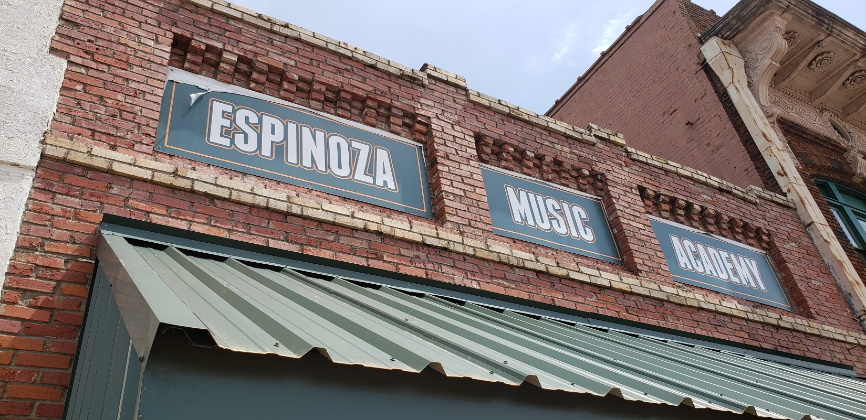Submit to: mainstreet-reports@thc.texas.gov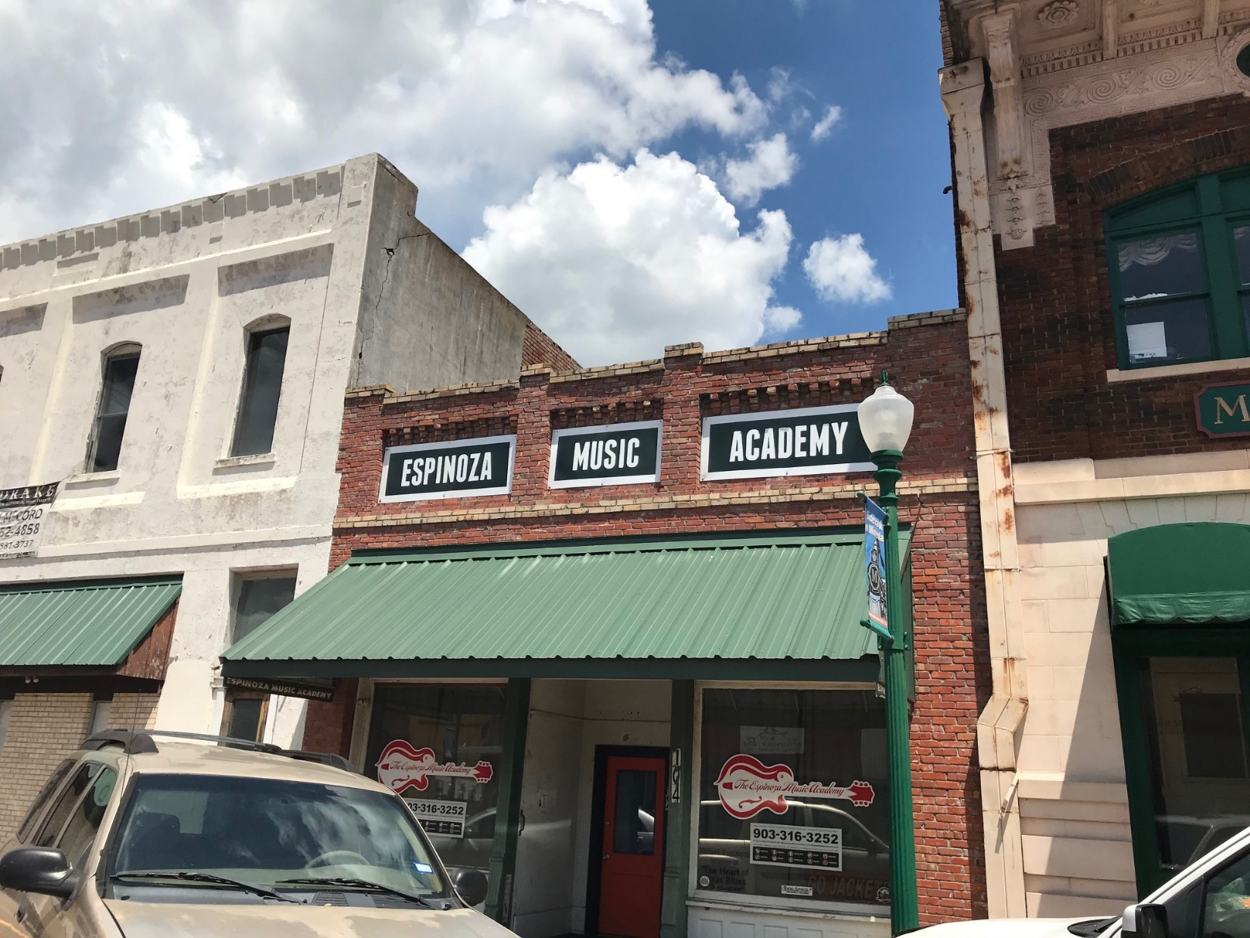
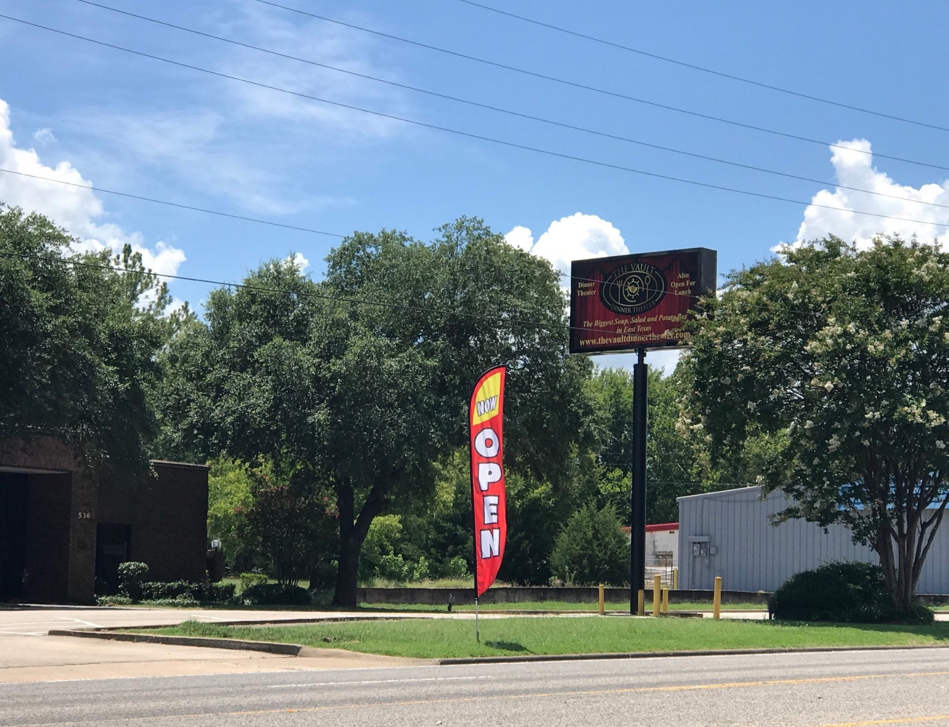
We did not give grant for the banner flag, but for the sign on the pole.
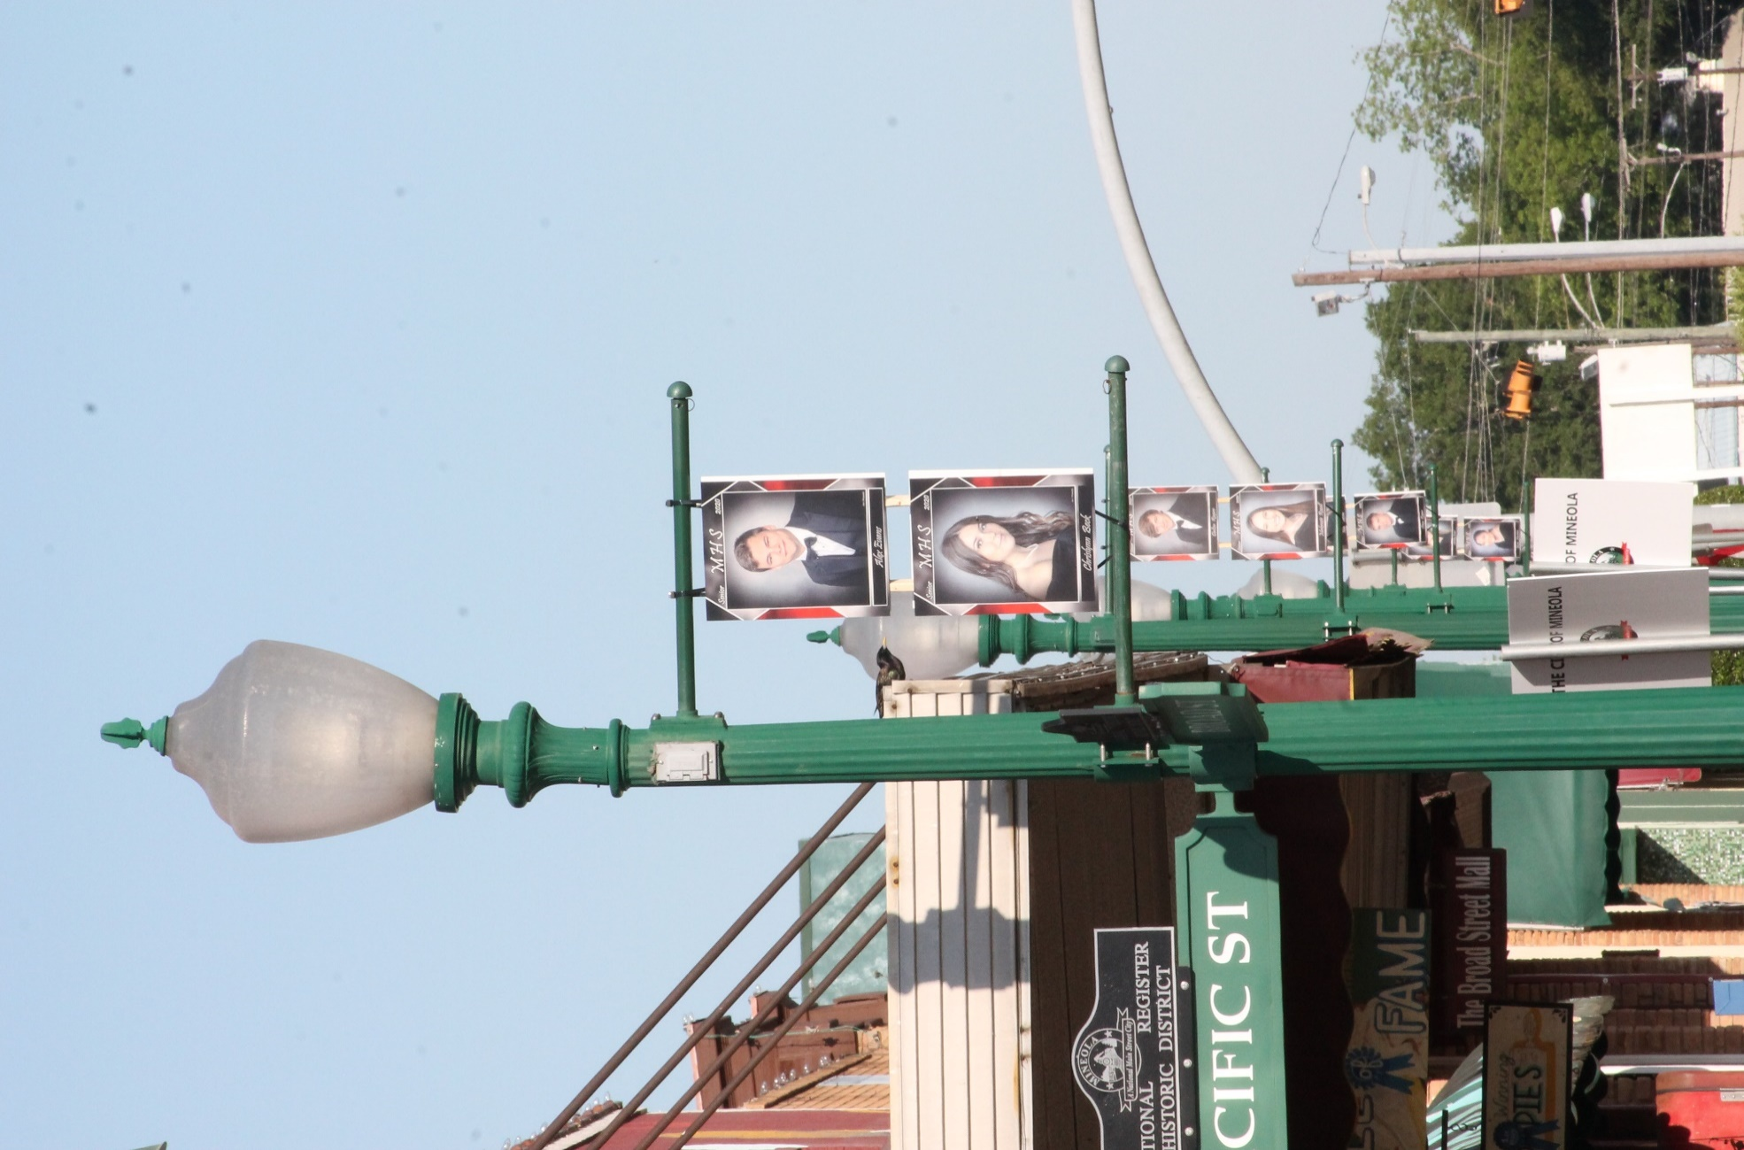
Senior photos on the lamp post arms and reserved parking for carryout, takeout customers are in lower part of photo.
